Project Design Phase-II
Technology Stack (Architecture & Stack)

Date
Team ID
Project Name
Maximum Marks | 4 Marks

Technical Architecture:
The Deliverable shall include the architectural diagram as below and the information as per the table1 & table 2
Example: Order processing during pandemics for offline mode
Reference: https://developer.ibm.com/patterns/ai-powered-backend-system-for-order-processing-during-pandemics/
Guidelines:
Include all the processes (As an application logic / Technology Block)
Provide infrastructural demarcation (Local / Cloud)
Indicate external interfaces (third party API’s etc.)
Indicate Data Storage components / services
Indicate interface to machine learning models (if applicable)


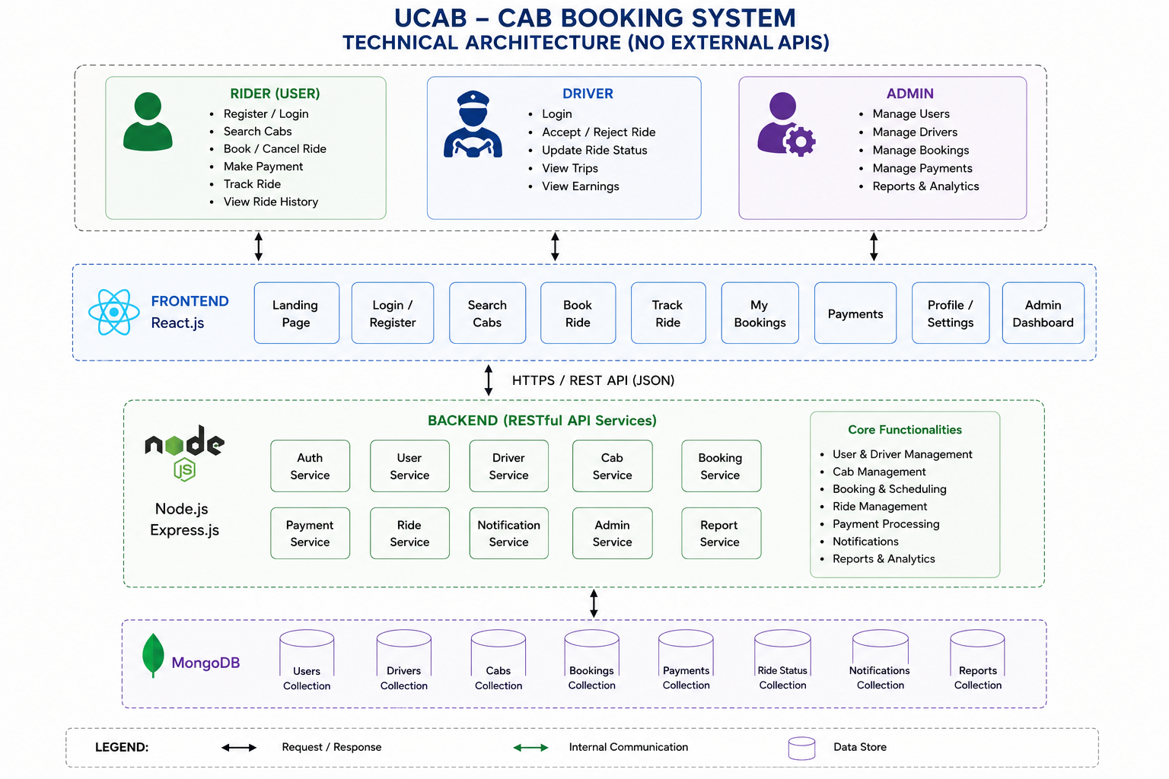
Table-1 : Components & Technologies:
S.No | Component | Description | Technology
1 | User Interface | Responsive web interface for users, drivers, and admin | HTML5, CSS3, JavaScript, React.js, Bootstrap
2 | Application Logic-1 | Authentication, user management, ride booking | Node.js, Express.js
3 | Application Logic-2 | Fare estimation, booking management, ride scheduling | Express.js, REST APIs
4 | Application Logic-3 | Payment processing and ride tracking | Axios, Socket.IO
5 | Database | Store users, drivers, bookings, payments | MongoDB, Mongoose ODM
6 | Cloud Database | MongoDB cloud database | MongoDB Atlas
7 | File Storage | Store profile images and ride receipts | Local Storage / Cloudinary
8 | External API-1 | Location and route services | Nomination API
9 | Machine Learning Model | Not Applicable | N/A
10 | Infrastructure (Server / Cloud) | Application deployment | Localhost / Render / Vercel / MongoDB Atlas

Table-2: Application Characteristics:
S.No | Characteristics | Description | Technology
1 | Open-Source Frameworks | Frameworks used for frontend and backend development | React.js, Node.js, Express.js, Bootstrap
2 | Security Implementations | Secure authentication and password protection | JWT, bcrypt.js, HTTPS, CORS
3 | Scalable Architecture | Three-tier architecture supporting future expansion | MERN Stack, REST API
4 | Availability | Application available through cloud deployment with reliable database connectivity | Render, Vercel, MongoDB Atlas
5 | Performance | Optimized APIs, efficient database queries, fast frontend rendering | React.js, MongoDB Indexing, Axios

References:
https://c4model.com/
https://developer.ibm.com/patterns/online-order-processing-system-during-pandemic/
https://www.ibm.com/cloud/architecture
https://aws.amazon.com/architecture
https://medium.com/the-internal-startup/how-to-draw-useful-technical-architecture-diagrams-2d20c9fda90d

